H.T No
Regulations:
A18

Sreenidhi Institute of Science and Technology
(An Autonomous Institution)
Code No: 7A304 Date: 23-Dec-2022 (FN)

B.Tech II-Year I- Semester (A18) Special Supplementary Examination - December-2022
ELECTRICAL CIRCUITS AND NETWORKS – II (EEE)

Time: 3 Hours Max.Marks:70

Note: a) No additional answer sheets will be provided.
b) All sub-parts of a question must be answered at one place only, otherwise it will not be valued.
c) Missing data can be assumed suitably.

ANSWER ANY 5 OUT OF 8 QUESTIONS. EACH QUESTION CARRIES 14 MARKS.

Bloom's Cognitive Levels of Learning (BCLL)
Remember | L1 | Apply | L3 | Evaluate | L5
Understand | L2 | Analyze | L4 | Create | L6

 |  |  | BCLL | CO(s) | Marks
1. | a) | What is the effect of variation of power factor on the readings of two-watt meters used in 3-phase power measurement? | L1 | CO1 | [7M]
 | b) | Determine the line currents in an unbalanced star connected load supplied from symmetrical three phase 440v system. The branch impedances are  Z_{R} =4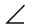30⁰, Z_{Y} =1045⁰ and Z _{B}=1060⁰. The phase sequence is RYB. | L5 | CO1 | [7M]
2. | a) | Illustrate the expression for transient response of RC series circuit excited by a sinusoidal source. | L2 | CO2 | [7M]
 | b) | Analyze DC response of series R-L circuit using Laplace Transform approach. | L4 | CO2 | [7M]
3. | a) | Explain the necessary conditions for driving point functions. | L2 | CO3 | [7M]
 | b) | Explain the properties of Transfer functions. | L2 | CO3 | [7M]
4. | a) | Obtain h-parameters in terms of Z-parameters | L3 | CO4 | [7M]
 | b) | Determine ABCD parameters of the two port network shown in the below Figure.  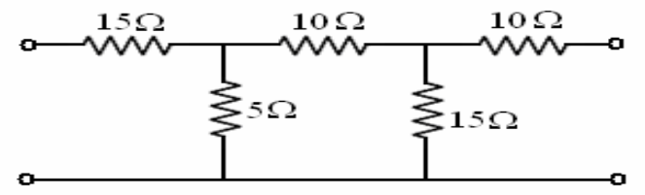 | L3 | CO4 | [7M]
5. | a) | Draw the circuit diagram of a low pass filter. Explain the design procedure of the above filter in detail. | L2 | CO5 | [7M]
 | b) | Explain the general configuration and parameters of a high pass filter T and π – Sections. | L2 | CO5 | [7M]
6. | a) | Derive the trigonometric Fourier series for the following periodic waveform.  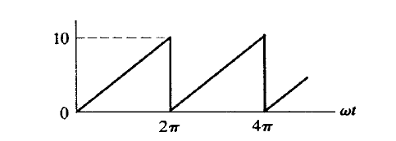 | L3 | CO6 | [7M]
 | b) | Explain about Even function symmetry and Odd function symmetry. | L2 | CO6 | [7M]
7. | a) | The two watt meter readings in a 3 - phase power measurement are 800W and 400W. The later reading is being obtained after the reversal of current coil. Calculate the total power and power factor of the load. | L3 | CO1 | [5M]
 | b) | Explain the procedure adopted for the evaluation of initial conditions. | L2 | CO2 | [5M]
 | c) | Explain the restrictions of pole zero locations for driving point functions. | L2 | CO3 | [4M]
8. | a) | In a two-port network, A=3, B=6, C=5, D=4. Compute Z₁₁ and Z_{12.} | L3 | CO4 | [5M]
 | b) | Write short notes on high Pass filter. | L1 | CO5 | [5M]
 | c) | Find the Fourier series expression for a symmetrical square wave signal. | L1 | CO6 | [4M]

-- 00 -- 00 –

